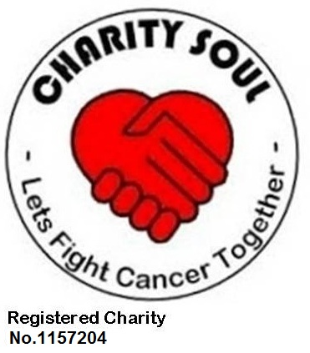

INFORMATION PACKAGE for
PROSPECTIVE ATTENDEE’S to CHARITY SOUL
FESTIVAL of SOUL in
SERENA GOLF COMPLEX

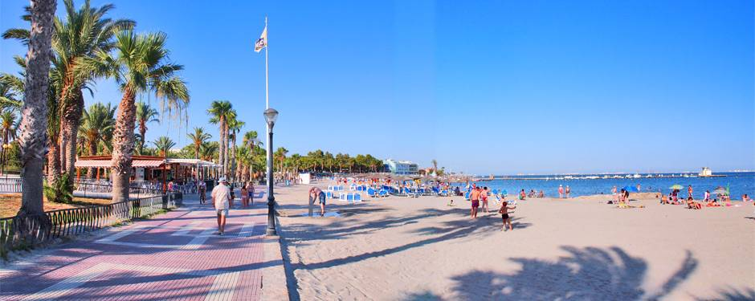
Los Alcázares playa
ach, Los Alćazares

Revised: 8/11/2021
GETTING THERE

Flights are available from most Airports in the UK, Leeds/Bradford, Manchester to the
new Regional Spanish Airport of Corvera, Murcia.
Alternatively, you can fly to Alicante and take transport from there to Los Alcázares

Flights can be obtained from Manchester, Leeds Bradford or East Midlands with Jet2 or Ryanair to Corvera

GETTING TO LOS ALCAZARES (for your Hotel)

If you are staying in Los Alcazares, which we recommend, it is a 33 minutes journey to your destination from the new airport of Corvera
Taxis are available outside the main terminal of Corvera Airport to Los Alcazares

ACCOMMODATION

Charity Soul have spoken to the local 4 Star Hotel Costa Narejos in Los Alcazares, who are willing to offer a special rate to people staying at the hotel during this period.
The hotel is 100yds. from the lovely beaches of the Mar Menor and near to many restaurants and bars.
More details can be obtained from the hotel’s web site:
www.hotelcostanarejos.com

If you want to book your accommodation then contact the Hotel Manager, Angel:
angel@hotelcostanarejos.com

Other hotels in Los Alcazares are:
Hotel 525
www.525.es

Hotel Los Narejos
www.hotellosnarejos.com

If you prefer self-catering then there are many apartments to rent locally from:
www.ownersdirect.co.uk
www.holidaylettings.co.uk/LosAlcazares
www.booking.com/losalcazares

EVENT START TIME

We will commence the evenings entertainment at Serena Golf Complex each day from 17.00hrs until late……

GETTING TO THE SERENA GOLF COMPLEX
The Festival of Soul with be held in the Serena Golf Complex just outside Los Alcazares, which is approximately 5kms from the Hotel Costa Narejos, Los Alcazares and is easily reached by local taxi, or if you’re feeling in a regal mood by horse and carriage.

Taxis
Asociación Radio Taxis los Alcázares los Narejos Murcia
34 968 57 41 05

Tomás Bernal Martínez

34 629 23 54 27

Taxi N°1 Los Alcázares Los Narejos
34 636 38 36 08

Map - Hotel Costa Narejos to Serena Golf Complex

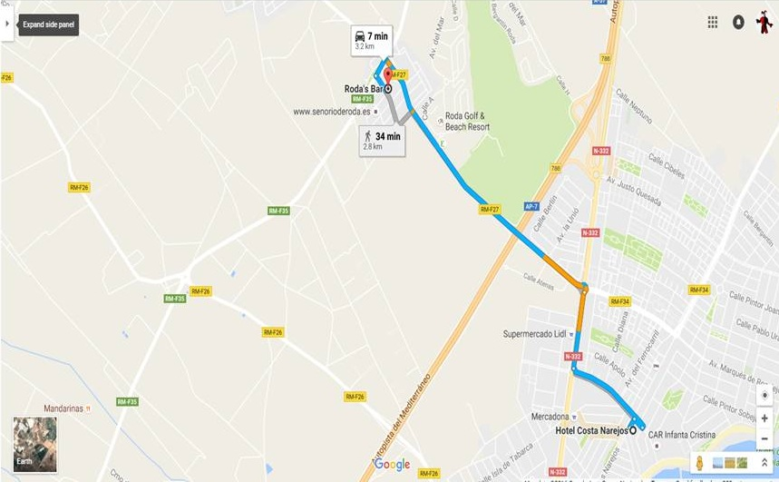
The event will be staged on the upstairs veranda in the Serena Golf Complex, if you are going
by taxi then ask for:
‘SERENA GOLF COMPLEX, AVENIDA PRINCIPE FELIPE 30’

Location of Serena Golf Complex

From Hotel Costa Narejos/Los Alcazares

Festival of Soul and Motown

Note: The Hotel Senator Mar Menor is not part of the Festival of Soul

Tickets for the whole weekend on Friday, Saturday, and Sunday, can be obtained from our web site:

www.charity-soul.co.uk

or contact:

Dave Johnson tel. 07487 589178
Email: rockhilldave9@gmail.com

Any other information regarding the Festival of Soul can be obtained from:
Terry Hopkinson 07976 382342
Tony Jackson 07882 716405

Veranda in Serena Golf

¡Va a ser un evento brillante!

